NJ Hurtok Сходини 6/4/2020 MINUTES
In attendance: Roma M (Host of Zoom), Zezya, Nusia D, Ruta, Louisa, Roxy K, Margareta, Darka P, Marta P, Lesia S, Natalka S, Petrusia, Roksolana M Lida C, Zenia (Irka D, Christia D and Katia S tried to join but could not log in)
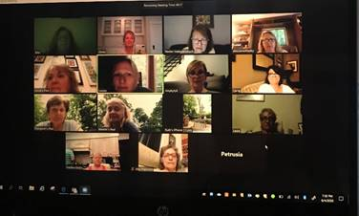
Opravdeni: Marta T (she said to say hello to everyone), Slava and Lyalya
1) Thank you all who participated. It was really great seeing your faces and hearing your voices!

2) Thank you again to all who donated baked goods for Laryssa Patti’s ER staff at RWJUH!

3) Congratulations to Darka P. Laryssa is expecting a baby in November!!

4) Tansti at the center were mentioned– Many were surprised that Andrij Cybak has been having virtual tansti classes with all his students. Zezya mentioned she can hear her son Mykola during the class dancing upstairs.

5) Profiles on Shutterfly: Zezya shared her screen with everyone and did a presentation/explanation of how to upload our photo that was taken at Rada. Shutterfly will only allow the individual to upload their own photo.(Even Zezya as an Administrator does not have that ability). For those not in attendance please login to Shutterfly and follow the detailed instructions that Zezya wrote. If you do not see your photo please take one in your plast shirt and or kiptar.

6) Rada 2020 was brought up. Petrusia informed us that all reservations at Soyuzivka have been cancelled up to and including Labor Day. However Petrusia is very optimistic that the wellness event is still scheduled for the end of the month. So if anyone wants to attend please call Soyuzivka to rebook. As for Rada we have not heard anything yet.

7) We shared experiences of our members and family who are front line healthcare workers during this pandemic. Roxy shared her experiences. Stefko Sikorskyj, Danyo Maksymovich, Larrysa Patti were mentioned. Margareta’s daughter Melania continues to work in her regular department and does not treat covid patients. It was also mentioned that Lida Buniak’s sons and Roma Temnycka’s daughter Ivanka are frontliners as well. We sent a Thank you “shout out” to all!

8) Fun stories were shared stories about our “in home salon treatments/services”. Cutting our own hair, No makeup for months, Nusia had great advice. “Go try on a pair of pierced earrings to make sure the holes didn’t close up!

9) We started talking about Wildwood but unfortunately our time ran out on ZOOM and our meeting was cut off.

10) Things we didn’t get a chance to discuss:

a. Do we want to do another dobre dilo? If so what type? Help another healthcare front liner with baked goods etc.. Any other ideas?
b. Regarding next skhodyny: Usually there are no skhodyny during the summer but due to the circumstances maybe another Zoom or outdoor get together within the next two months is a possibility.

THANK YOU AGAIN Roma for setting up this ZOOM meeting (twice!)

Stay safe – Be well – Until next time

Zenia and Lida

