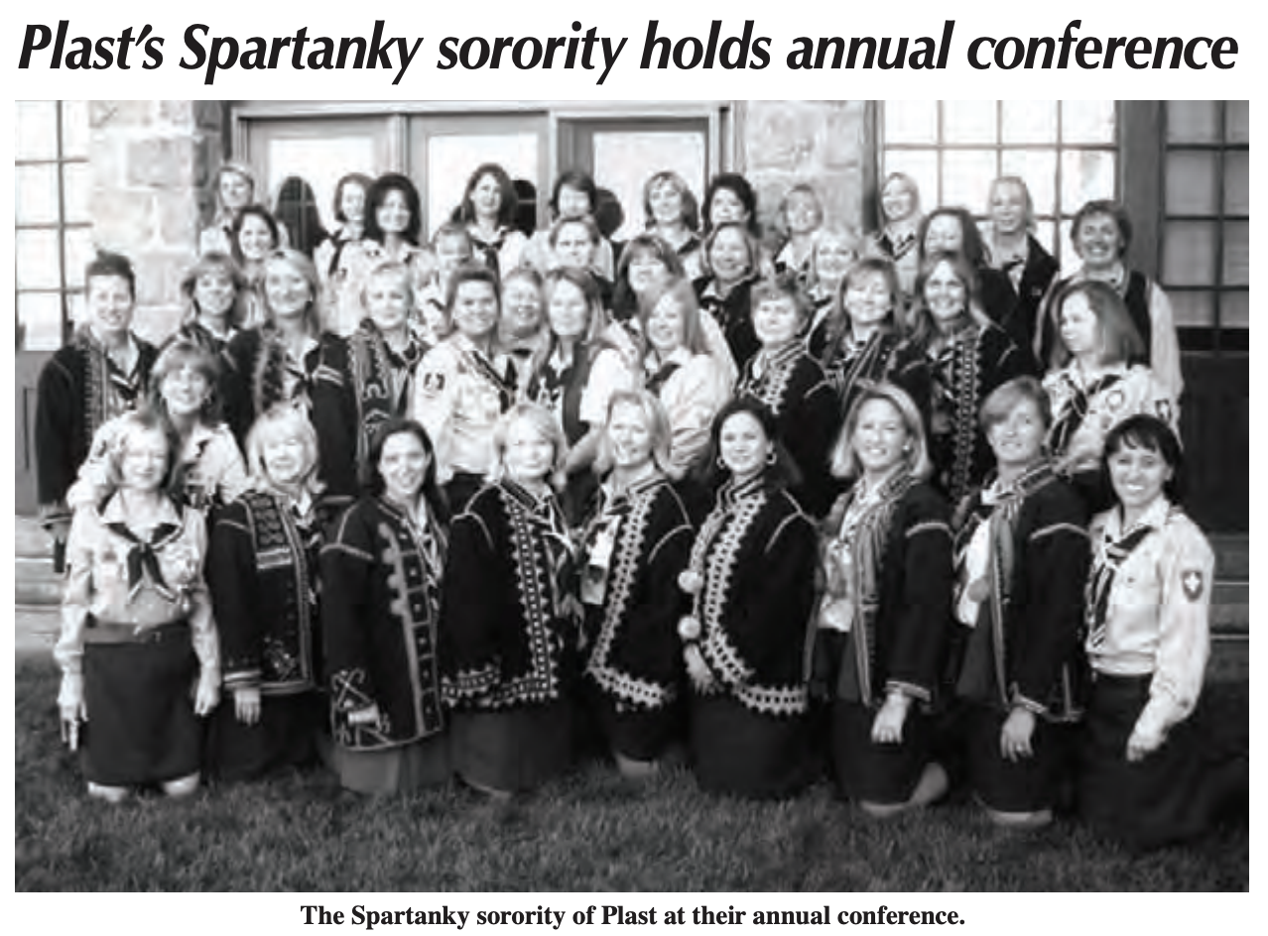

by Vera Chuma-Bitcon SLOATSBURG, N.Y. –

Forty members of the Plast sorority Spartanky from the tri-state area and Philadelphia gathered here on September 19-20 to hold their annual “rada,” or conference. Outside, under a starlit sky on the stately property of the Sisters Servants of Mary Immaculate, the women held their opening ceremony, which included the induction of four new members: Iryna Juravich, Louisa Kaminskyj, Marta Popovich and Roma Temnycky. The New York/New England branch organized the weekend’s events, including a very well performed mystery theater act. On Saturday the Spartanky discussed plans for the upcoming year. These women are very active year round in the administration of camps and in their local Plast branches. Volunteering their time to Plast and financial supporting Plast causes is second nature to them. Next year once again these women will run the popular oneweek camp at East Chatham, N.Y., for six-year-old first-time campers. They will also continue to run the two days of activities required to earn the Plast physical fitness badge for campers in East Chatham. In addition, they are planning a specialized camp for horseback riding. Spartanky re-elections took place at the conference and the newly elected president is Chrystia Kotlar, vice-president – Petrusia Paslawsky, secretary – Vera Chuma-Bitcon and treasurer – Christa Kozak.

