11/3/2020
ADDENDUM to 10/13/2020 MINUTES from Hurtkovi Skhodyny
#1 Mini Rada Theresa responded and prefers attendance to the upcoming mini Rada to only be the kurinnyj provid, hurtkovi and committee heads. She has assured us that no major decisions will be made. If anyone has a specific topic that needs to be discussed at this mini rada please contact her directly.
#7 Spartanky Babstia’s Congratulations Darka Patti! Her daughter Laryssa gave birth to a baby boy on 10/29. Leo Joseph Jensen. Mother and baby are doing well.
#8 Babstia Christmas ornaments: Thank you Nusiu for your update on ideas and materials needed. Please read her message:
“Hello darlings:
Following up and sharing info regarding the little tree ornament pillows discussed at meeting.
I wanted to see what is out there in our colors, from suppliers I’ve dealt with (this company supplied the ultra fine linen for Whippany altar that is the layer required to be between brocade altar cloth and wood altar: the things I learned I didn’t know for the church opening).
Playing with design ideas :Square shape, hanging as diamond; black & gold DMC threads braided, then creating loop for hanging. We can do one side gold linen, with black/multi thread for baby initials/vzir; other side black linen with gold xpectyky mimicking our xyctka stripes for the back = our signature?! They have DMC threads. Or could be both white sides; or one black other white; or gold side/white side linen. Just tossing out thoughts, will go with what you like.
A place to start . . . Tsioms and tulles, Nusia “

## Missing from Minutes:
Petrusia reminded us that we discussed the following:
Message from Petrusia:
“Spartanky Seniory got the top VFV standing out of all the kureni. I think it was sort of a big deal since our kurin and name Spartanky was associated with physical fitness and athletics. Maybe we could continue to send pictures to our xponika (another contest and winners ceremony for the season) this during the pandemic so that we stay well and encourage our family and friends around us during the winter and spring seasons. Also maybe the STPs would participate as well. What do you think?
I found this on Athletics https://en.wikipedia.org/wiki/Women_in_ancient_Sparta
Spartan bronze figure of a running girl, wearing a single-shouldered chiton (British Museum)
Unlike elsewhere in Greece, in Sparta, unmarried girls regularly participated in sports.[19] The Spartan exercise regimen for girls was designed to make them "every bit as fit as their brothers",[20] though unlike their brothers they did not actually train for combat.[21] In his Constitution of the Spartans, Xenophon reports that Lycurgus required that women should exercise just as much as men, and to this end instituted athletic competitions for women.[19]
Early sources report that Spartan girls practiced running and wrestling; later texts also mention throwing the javelin and discus, boxing, and pankration.[22] They also learned to ride on horseback.[23] There are votive offerings that have been discovered depicting Spartan women on horseback.[24] It is possible that Spartan girls exercised naked, because Archaic Spartan art portrays naked girls, unlike the art of other areas of Greece.[9] Girls might have competed in gymnopaedia, the Spartan festival of youths.[25] They also competed in running races for various festivals, of which the most prestigious was the Heraean Games.[26] Upon marrying, Spartan women likely ceased participating in athletics.[27]
Interesting story to tell. Stay healthy. Petrusia “
---------------------------------------------------------------------------------------------------------------------
After the mini rada we will update the hurtok.
Stay safe! Lida and Zenia
----------------------------------------------------------------------------------------------------
ZOOM Spartanky NJ Hurtkovi Skhodyny 10/13/2020 MINUTES
In attendance: Slava H(Host of Zoom), Irka D, Nusia D, Marta M, Christia S, Zezya Z, Anya T, Lyalya N, Oksana H, Ruta L, Louisa K, Roxy K, Margaret N, Darka P, Petrusia P, Marta L, Danusia M, Lida C, Zenia

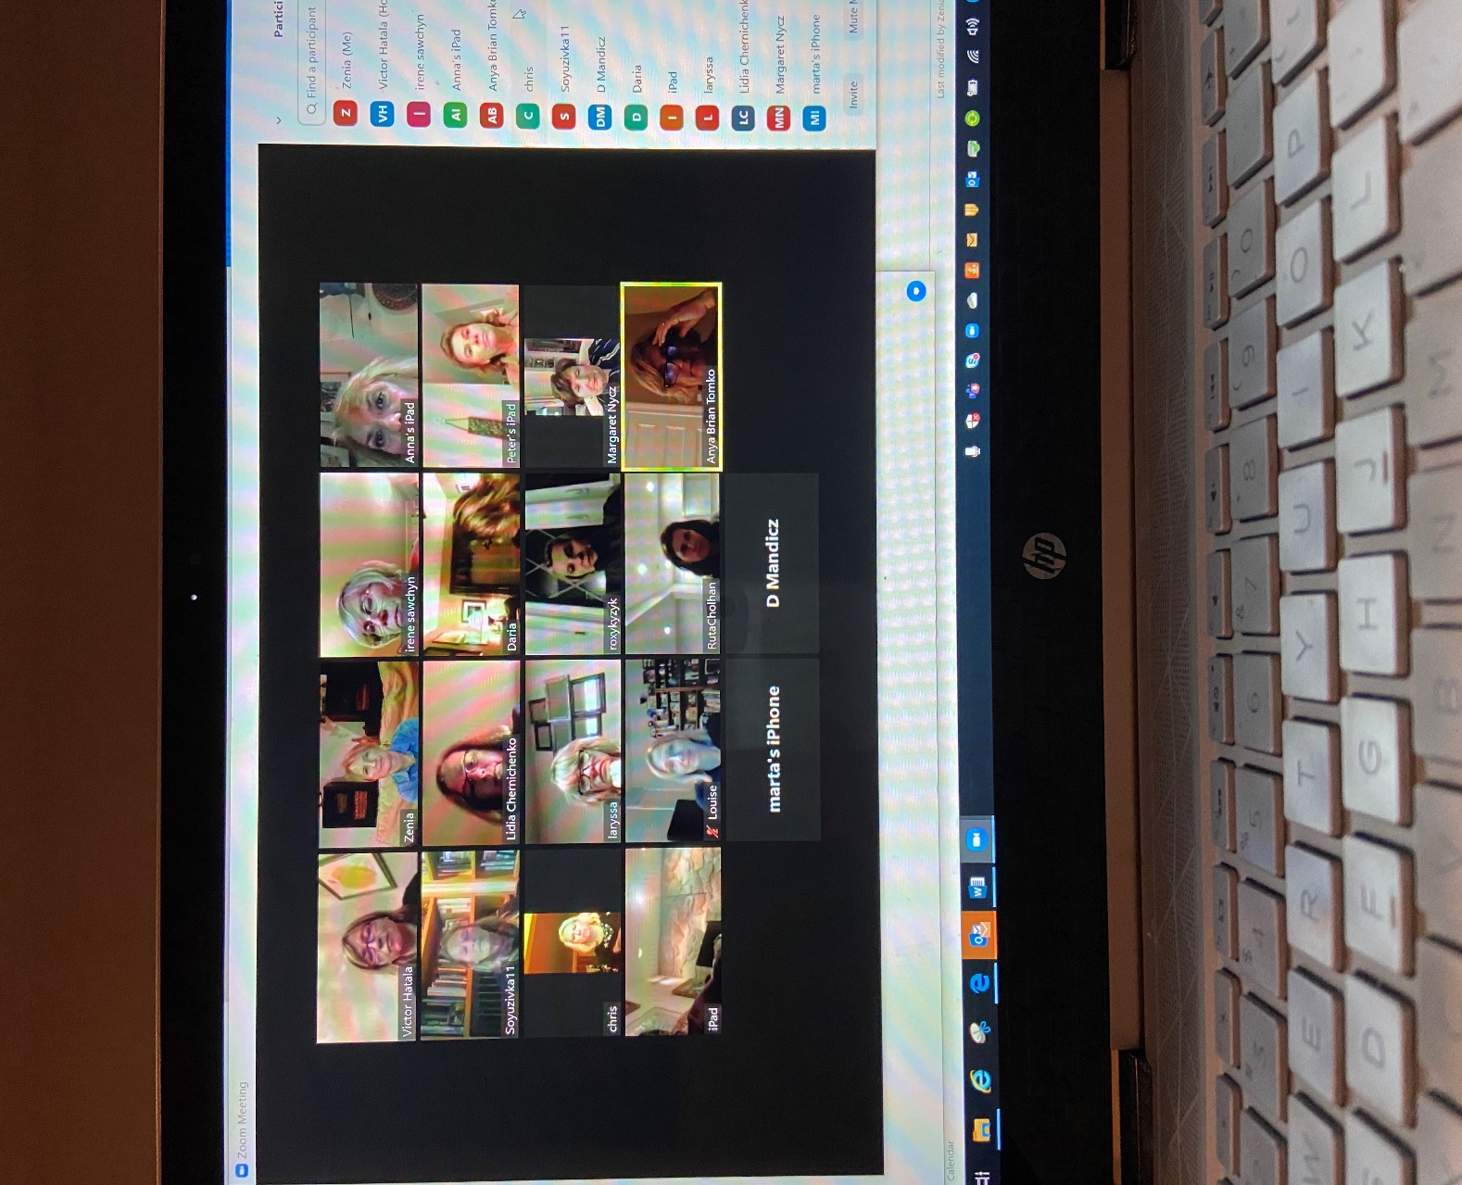

Opravdeni: Marta P, Roma M and Natalka S
- Rada 2020: Rada has been canceled for 2020. A mini rada will be held with the kurinnyj provid, hurtkovi and committee heads on 11/8/2020 via Zoom. Darka P asked if this Rada was open to all. Lida C will look into it.
Note: There is a tentative date for our Rada in April 2021 at Soyuzivka.

- Referent Senioriv Newark: Irka D will be leaving her post and asked if anyone was interested in taking her place. Irka brought up a virtual Zoom Plast Christmas Party this year. She asked Zenia to contact the STP’s if they would be interested in organizing: technical set-up as well as organizing the event. Discussion was that it would be difficult to have more than 20 on a call. An idea came up to have entertainment while all others were muted. This is all dependent on the Newark Stanytsia’s provid to want us to pursue this – Irka to confirm.

- Vkladka $35.00: send in your vkladka to Christia Stasiuk-4 Lenox Road. Rockaway, NJ 07866

- Hurtkova 2020-2021: Lida and Zenia will continue as co-hurtovis’ with the addition of Christia S !!!

- Mayno – Christia Stasiuk is asking if anyone has any kurinne mayno to please send your list to her ASAP. This needs to be included in her zvit for the upcoming mini rada 11/ 8

- Dobre Dilo: Was discussed that several different projects can be done as a large or small group, individually or in pairs.

  - Lida and Zenia have volunteered to help with the Hoverlia membership and payment of dues. Updating membership list. Setting up the Micros computer to give membership numbers, etc. Zezya will forward the information that she has regarding current members.
  - Anya and Zezya brought up the idea of helping Plast with interesting virtual hutirky – They mentioned Petrusia and beekeeping. Is there a vmilist? etc. They will look into this and any other ideas
  - Open to all - Varenyky at the center – on selected Tuesday’s there will be varenyky making sessions at the UACCNJ kitchen– plan is to sell throughout the year to help raise money for the center.
Message from Ira Gavrysh: New Date 10/20/20
PREPARE POTATOES FROM 10 AM,
MAKING VARENYKY FROM 1 PM.
RSVP to vgavrysh@aol.com

- Congratulations to Darka Patti and Marta M expecting a grandchild in November and Lyalya in February.
- Spartanky babtsia gift was discussed. Making embroidered Christmas ornaments personalized with name and year born. Spartanky themed or Ukie vzory or both… Nusia D is looking into supplies. Fun way to get together – or we can zoom while each are embroidering… Will make for all babsti. We will bring this up at the mini rada to see if the kurin is interested in making this a kurinnyj effort. If not, it will be just for our hurtok.
- Zezya announced the upcoming surprise birthday party at the center for Andrij Cybak on 10/25 5pm. This is to thank him for his hard work at the center. Only those who know him well should attend due to social distancing issues. If you will be attending please RSVP Zezya. If you’d like to give a gift please contact Irka D.
- Kutya- Since there is uncertainty about having a Bazaar this holiday season Margareta asked if there will be any mak and pshynytsia for sale. Zezya/Anya will ask the Lanka Batkiv. Maybe a drive thru set up can be arranged.
- Newark Deb may be held on 5/22/21 at the Westin Hotel in Jersey City. Not finalized yet. Zezya/Anya will get back to us on that.
- Irka D mentioned a Soyuz Ukrainok Branch 75 fundraiser selling candles, wrapping paper etc. She will be sending out an email to all. Irka will also send an invite to the next Soyuz Ukrainok Zoom meeting to all Spartanky.
- We received a question why our Zoom/in person skhodyny were cancelled for 9/8. This was because very few people responded. Lida and I explained that RSVPing is VERY important. Everyone should be responding yes/no/or maybe to every skhodyny. Due to the low count we the hurtkovi’s decided to find another day that would be better attended – which we did on 10/13
- We discussed the fact that the STPs have videos from last year’s rada – the terenova hra, etc. They actually have more than what was shown at rada. There is interest in seeing these. Zenia will contact STP’s
- After the mini rada is held we will schedule skhodyny to discuss what was discussed, any decisions that were made, etc.
- It was such a pleasure seeing you and hearing your voices and your laughter Stay safe… until next time ….. be well
Lida and Zenia

