KT Committee Zvit 2024
KT Committee membership: Nadia Gluch (head), Louisa Kaminsky, Petrusia Paslawska, Lesia Kozicky, Zina Zinych, Teresa Kuritza.
We hosted a one-day visit for yunatstvo to Hidden Hollow Farm in Milan (Red Hook), NY on Sunday, November 5th, 2023.
- We had a total of 10 participants. 13 were signed up but 3 did not show.
- The official time for the event was 12:00 – 2:30, but many participants lingered a little longer to help with feeding the horses and turnout.
- The participants took turns grooming the horses and learned about horse handling, safety and how to place the riding equipment on the horse (tacking up). Each participant had the opportunity to take a short ride under the lead of a handler in a riding ring that was set up with some turns and minor (non jumping) obstacles.
- The participants were shown how to set up the grain for the horses and put the grain buckets in their stalls.
- Every participant got a vidznaka and a bagged lunch to go.
- The facility operator charged $15 per rider. We charged $20 per participant to cover the rider fee plus the costs of the vidznaky, lunch and tips for the handlers. I collected the cash from the parents and wrote one check to Hidden Hollow Farm for $150.
- Thank you to Katia Kaniarska who came to help out for the day.
- The participants were able to earn some of the requirements for the vmilist during this event. After the event, everyone was emailed written materials that had to be completed and returned to me to finish the requirements. Two yunachky did so and earned the vmilist. I sent their posvidky via email.
Overall, everyone seemed very pleased with the event. The weather was fantastic! The handlers were impressed that our yunatstvo were all so attentive, inquisitive and of course well behaved. We are planning a similar event to take place at Little Brook Farm in Old Chatham, NY on November 23, 2024.
We pursued the possibility of attending an all-inclusive weekend at the Rocking Horse Ranch in Highland, NY but determined this to be cost prohibitive.
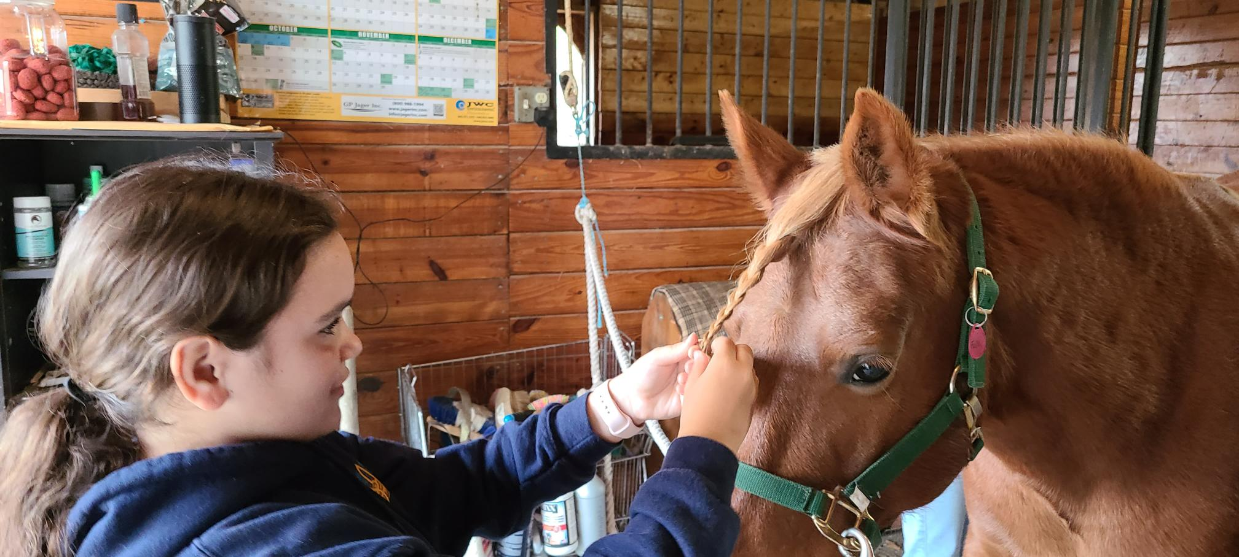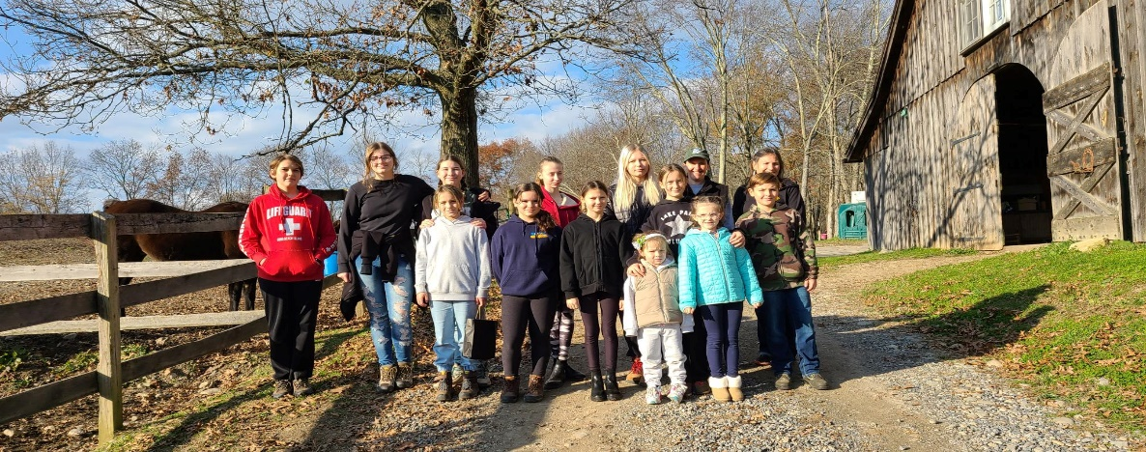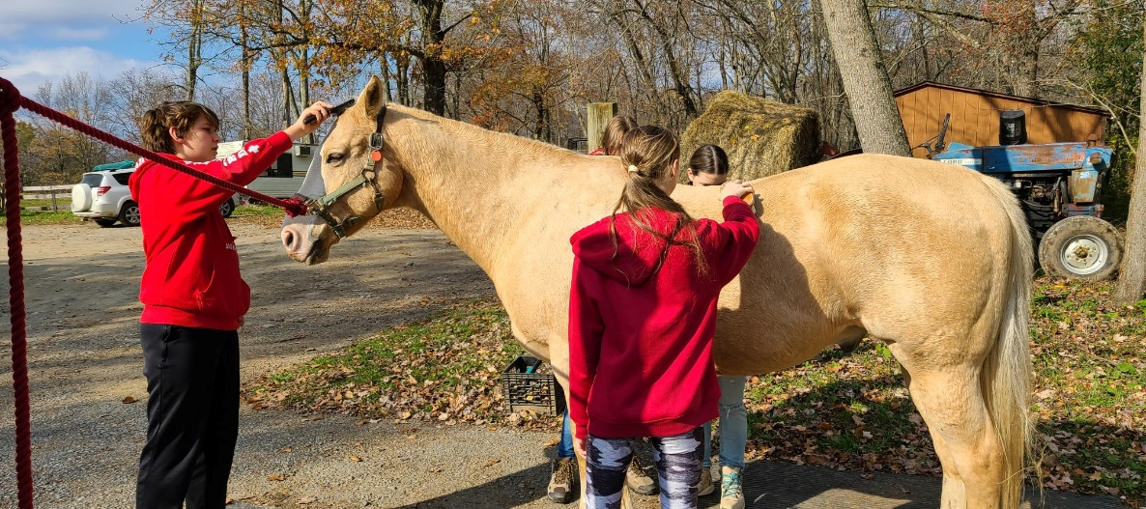
СКОБ!
Зі щитом!
Nadia Gluch, СП

